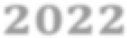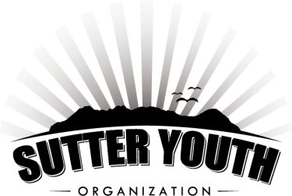
Season Pool
Pass

20
2
2

Butte House Road & Acacia Avenue
Sutter, California

Individual Season Pass  Membership Non-Membership $90.00 for one person (1) $100.00 for one person (1) | -Admission for one- for the 2022 season  -Not valid for special events  -2 individual activity trial passes of your choice
Family Season Pass  Membership Non-Membership  $180.00 for family of four (4) $200.00 for family of four (4)  Additional members - $45.00 Additional members - $50.00 | -Admission for family of 4- for the 2022 season  -Not valid for special events  -2 individual activity trial passes of your choice

FAMILY NAME: _________________________________
Name (s): |  |  |  | Ages:
1. ________________________________ |  |  |  | _________
2. ________________________________ |  |  |  | _________
3. ________________________________ |  |  |  | _________
4. ________________________________ |  |  |  | _________
5. ________________________________ |  |  |  | _________
6. ________________________________ |  |  |  | _________
 | Email: |  |  |  | Cell Phone Number:
 | Address: |  |  |  | Phone Number:
 | Emergency Contact: |  |  |  | Phone Number:

**Continued on Back**

RELEASE AND WAIVER OF LIABILITY (This is a legal and binding contract.)

“I am aware that accidents can happen around and in a swimming pool, and I or (my child/children/dependents) am voluntarily participating in the activities with knowledge of the dangers involved and hereby accept any and all risks of injury. I have carefully read this release and waiver and fully understand its content. I also understand that if I or (my child/children/dependents) do not follow the rules of the Morehead Family Community Pool and do not act in accordance with the instructions of the manages or lifeguards that I and/or my child(ren) may be asked to leave the premises. I fully understand that the managers have the duty to close the pool early in the event of extreme weather, water quality problems and/or low attendance (less than 12 swimmers) as agents of the SYO board. I am aware that this is a release of liability, including asserted negligence and is a contract between our family (including our guests) and the Sutter Youth Organization and its board members. I am signing this of my own free will. I agree that in the case of an emergency, illness and/or injury that the supervisor on duty has my permission to authorize emergency treatment for my minor age children.
I hereby give my consent to Morehead Family Community pool to photograph, film, videotape and then use, reproduce and publish said images of me and/or my children.”

__________________________________________________________ ___________________
Signature of Member Date

Date of purchase: _______________

Receipt # ______________________

Membership # __________________

Pool pass # _____________________

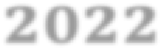
Season Pool
Pass

20
2
2

