Initial: ____________________
Date of purchase: ___________
Receipt #: __________________
Membership #: ______________
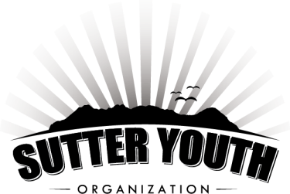

Butte House Road & Acacia Avenue
Sutter, California

Date Time  _____June 24th _____ 8am-1pm  _____July 8th _____8am-1pm  _____July 22nd _____8am-1pm  *Includes lunch (nachos and lemonade) and free open swim for the remaining of the day. | Membership  _____$18.00/child  Non-Membership  _____$20.00/child

Last Name:_____________________________________
Participant Name (s): Ages:
1. ________________________________ _________
2. ________________________________ _________
3. ________________________________ _________
4. ________________________________ _________
5. ________________________________ _________

Email: | Cell Phone Number:
Address: | Phone Number:
Emergency Contact: | Phone Number:

**Continued on Back**

RELEASE AND WAIVER OF LIABILITY (This is a legal and binding contract.)
“I am aware that accidents can happen around and in a swimming pool, and I or (my child/children/dependents) am voluntarily participating in the activities with knowledge of the dangers involved and hereby accept any and all risks of injury. I have carefully read this release and waiver and fully understand its content. I also understand that if I or (my child/children/dependents) do not follow the rules of the Morehead Family Community Pool and do not act in accordance with the instructions of the manages or lifeguards that I and/or my child(ren) may be asked to leave the premises. I fully understand that the managers have the duty to close the pool early in the event of extreme weather, water quality problems and/or low attendance (less than 12 swimmers) as agents of the SYO board. I am aware that this is a release of liability, including asserted negligence and is a contract between our family (including our guests) and the Sutter Youth Organization and its board members. I am signing this of my own free will. I agree that in the case of an emergency, illness and/or injury that the supervisor on duty has my permission to authorize emergency treatment for my minor age children.
I hereby give my consent to Morehead Family Community pool to photograph, film, videotape and then use, reproduce and publish said images of me and/or my children.”

_________________________________________ _____ ____________________
Signature of Member Date

